This Quick Start builds an informatics infrastructure for a biotech company on the AWS Cloud. It sets up a virtual data center by creating virtual private clouds (VPCs) and automatically configures this infrastructure for identity management, access control, encryption key management, network configuration, logging, alarms, partitioned environments (for example, to separate preclinical, clinical, and management processes), and built-in compliance auditing.

You can also use the Quick Start to automatically deploy the industry’s leading scientific research applications into this informatics infrastructure. Currently, you can deploy an electronic lab notebook (ELN), molecular R&D solutions, and a chemical compound registry. We'll be expanding the Quick Start Biotech Blueprint catalog to include laboratory information management systems (LIMS), screening tools, and freezer management tools. For more information, see the Add-on products tab.

This Quick Start was developed by  
AWS solutions architects.

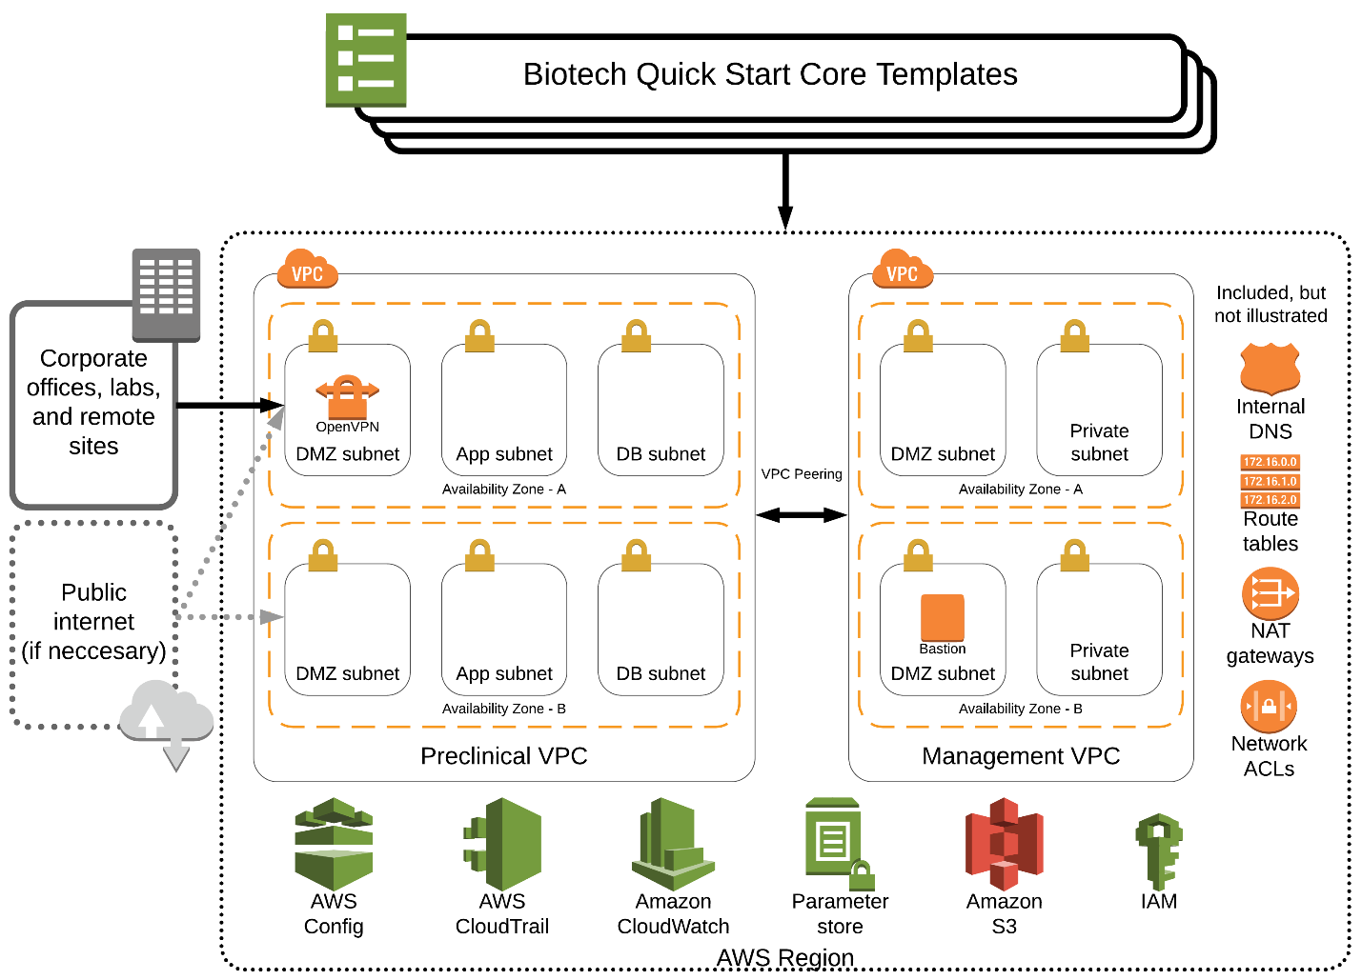

* What you'll build
* Add-on products
* How to deploy
* Cost and licenses
* This Quick Start sets up the following:
  + A highly available architecture that spans two Availability Zones.
  + A preclinical VPC configured with public and private subnets according to AWS best practices, to provide you with your own virtual network on AWS. This is where informatics and research applications will run.
  + A management VPC configured with public and private subnets, to support the future addition of IT-centric workloads such as Active Directory, security appliances, and virtual desktop interfaces.
  + An internet gateway to allow access to the internet for public resources.
  + Redundant, managed NAT gateways to allow outbound internet access for resources in the private subnets.
  + Certificate-based virtual private network (VPN) services through the use of OpenVPN.
  + A Linux bastion host to allow inbound Secure Shell (SSH) access to EC2 instances in public and private subnets. The bastion host is launched inside an Auto Scaling group of size 1 to ensure availability.
  + Private, split-horizon DNS with Amazon Route 53.
  + Best-practice IAM groups and policies based on separation of duties designed to follow the U.S. National Institute of Standards and Technology (NIST) guidelines.
  + A set of automated checks and alerts to notify you when AWS Config detects insecure configurations.
  + Account-level logging, audit, and storage mechanisms designed to follow NIST guidelines.
  + (Optional) Informatics software from leading biotech companies. For details, see the Add-on products tab.